**DOKUZ EYLUL UNIVERCITY**

**Faculty of Engineering**

**Electrical and Electronics Engineering**

**EED 1005 Introduction to Programming Laboratoary#8**

Student Name : Yavuz BALI Experiment Date: December 21,2016

Number:2014502021

**Preliminary Work:**

**TASK 1:**

#include<stdio.h>

#include<stdlib.h>

int main() {

int a[5]={17,21,3,0,5};//first method

int b[]={17,21,3,0,5};//second method

int c[5],i;//third method

for(i=0;i<=4;i++) {

scanf("%d",&c[i]);

printf("a[%d]=%d\n",i,a[i]);

printf("b[%d]=%d\n",i,b[i]);

printf("c[%d]=%d\n",i,c[i]); }

return 0;

system("PAUSE"); }

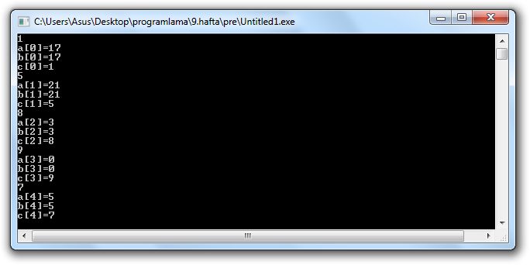

**TASK 2:**

a) int main() {

int a[5] = {5, 1, 15, 20, 25};

int i, j, m;

i = ++a[1];

j = a[1]++;

m = a[i++];

printf("%d, %d, %d", i, j, m);

return 0;

}

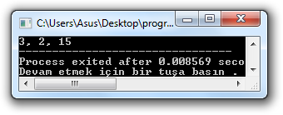

b) #include<stdio.h>

int main()

{

int arr[5],i=0;

while(i<5)

arr[i]=++i;

for(i=0;i<5;i++){

printf("%d\n",arr[i]);

}

return 0;

}

